1. What are the various elements of the Excel interface? Describe how  they're used.

The following are the basic parts of the Microsoft Excel Window:

* Quick Access Toolbar.
* File Tab.
* Title Bar.
* Control Buttons.
* Menu Bar.
* Ribbon/Toolbar.
* Dialog Box Launcher.
* Name Box.

1. Write down the various applications of Excel in the industry.

The main uses of Excel include:

* Data entry.
* Data management.
* Accounting.
* Financial analysis.
* Charting and graphing.
* Programming.
* Time management.
* Task management.

1. On the ribbon, make a new tab. Add some different groups, insert  commands in the groups and name them according to their commands  added. Copy and paste the screenshot of the steps you followed.

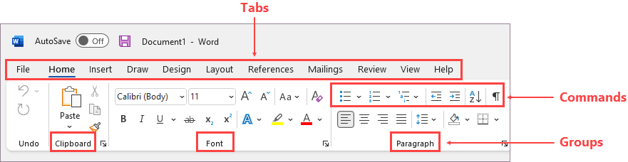

1. Make a list of different shortcut keys that are only connected to  formatting with their functions.

Italicize text or remove italic formatting – Ctr+I or Ctr+3

Bold text or removing the bold formatting – Ctr+b or ctr+3

Underline the text or remove underline – Ctr+U or Ctr+4

Apply or remove strike through formatting – ctr +5

1. What distinguishes Excel from other analytical tools?

* Pivot tables and pivot charts.
* Conditional formatting.
* Remove duplicates.
* XLOOKUP.
* IFERROR.
* MATCH.
* COUNTBLANK.
* DAYS and NETWORKDAYS